Bahria University,

Karachi Campus



COURSE: CSC-113 COMPUTER PROGRAMMING

TERM: FALL 2020, CLASS: BSE- 1 (B)

Submitted By:

M Muaz Shahzad 02-131202-081

(Name) (Reg. No.)

Submitted To:

Engr. Adnan ur rehman/ Engr. Ramsha Mashood

Signed Remarks: Score:

INDEX

|  |  |  |  |  |
| --- | --- | --- | --- | --- |
| SNO | DATE | LAB NO | LAB OBJECTIVE | SIGN |
| 1 | 28-sep 2020 | 01 | Programming Basics |  |
| 2 | 6-oct  2020 | 02 | Variable and Arithmetic operation |  |
| 3 | 13-oct 2020 | 03 | Input and Output |  |
|  |  |  |  |  |
|  |  |  |  |  |
|  |  |  |  |  |
|  |  |  |  |  |
|  |  |  |  |  |
|  |  |  |  |  |
|  |  |  |  |  |
|  |  |  |  |  |
|  |  |  |  |  |
|  |  |  |  |  |
|  |  |  |  |  |
| SNO | DATE | LAB NO | LAB OBJECTIVE | SIGN |
|  |  |  |  |  |
|  |  |  |  |  |
|  |  |  |  |  |
|  |  |  |  |  |
|  |  |  |  |  |
|  |  |  |  |  |
|  |  |  |  |  |
|  |  |  |  |  |
|  |  |  |  |  |
|  |  |  |  |  |
|  |  |  |  |  |
|  |  |  |  |  |
|  |  |  |  |  |
|  |  |  |  |  |
|  |  |  |  |  |

Bahria University,

Karachi Campus



LAB EXPERIMENT NO.

**01**

LIST OF TASKS

|  |  |
| --- | --- |
| TASK NO | OBJECTIVE |
| 01 | Write steps how to install visual studio |
| 02 | Show the output of all examples mention in the lab |
| 03 | Debug the program and the write the values of n, sum and m while debugging |
| 04 | Execute the program and show the output |
|  |  |
|  |  |
|  |  |
|  |  |
|  |  |
|  |  |
|  |  |
|  |  |
|  |  |
|  |  |
|  |  |

Submitted On:

21/10/2020  
 (Date: DD/MM/YY)

**Task No. 1: How to download and install visual studio?**

**Solution:**

* **Step 1:** Search on Google visual studio 2015
* **Step 2:** Go to official website link
* **Step 3:** Scroll Down and click 2015
* **Step 4:** Then click on download
* **Step 5:** Wait for the link to open
* **Step 6:** One left side in “Filter” column select visual studio 2015
* **Step 7:** Click on download button (at right side)
* **Step 8:** After completion, open the installer select default installation and wait for the completion
* **Step 9:** Open the 2015 after installation and create account

**Task No 2: Show the output of all examples mention in the lab**

**Solution:**

**Example 1**

using System;

using System.Collections.Generic;

using System.Linq;

using System.Text;

using System.Threading.Tasks;

namespace ConsoleApp1

{

class Program

{

static void Main(string[] args)

{

Console.WriteLine("M Muaz Shahzad");

}

}

}

**Output:**

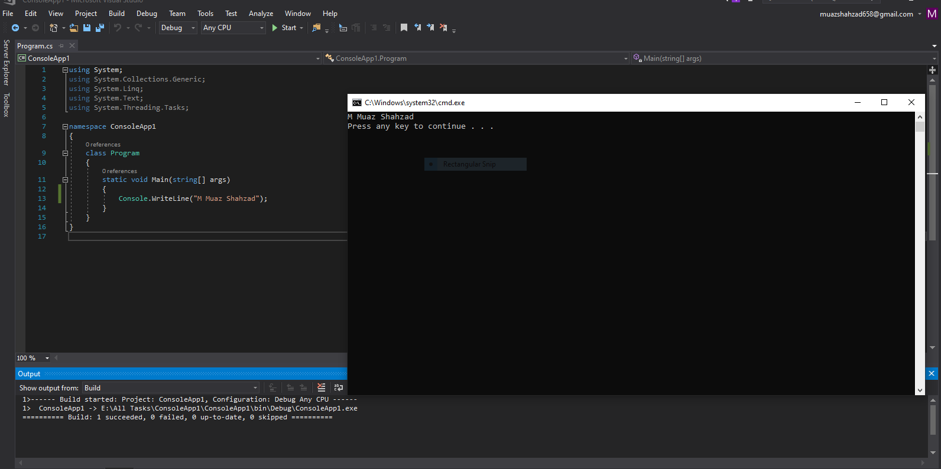

**Example 2:**

**Solution:**

using System;

using System.Collections.Generic;

using System.Linq;

using System.Text;

using System.Threading.Tasks;

namespace ConsoleApp1

{

class Program

{

static void Main(string[] args)

{

string name;

Console.Write("write your name \n");

name = Console.ReadLine();

Console.WriteLine("my name is \n \"" + name +"\"");

}

}

}

**Output:** 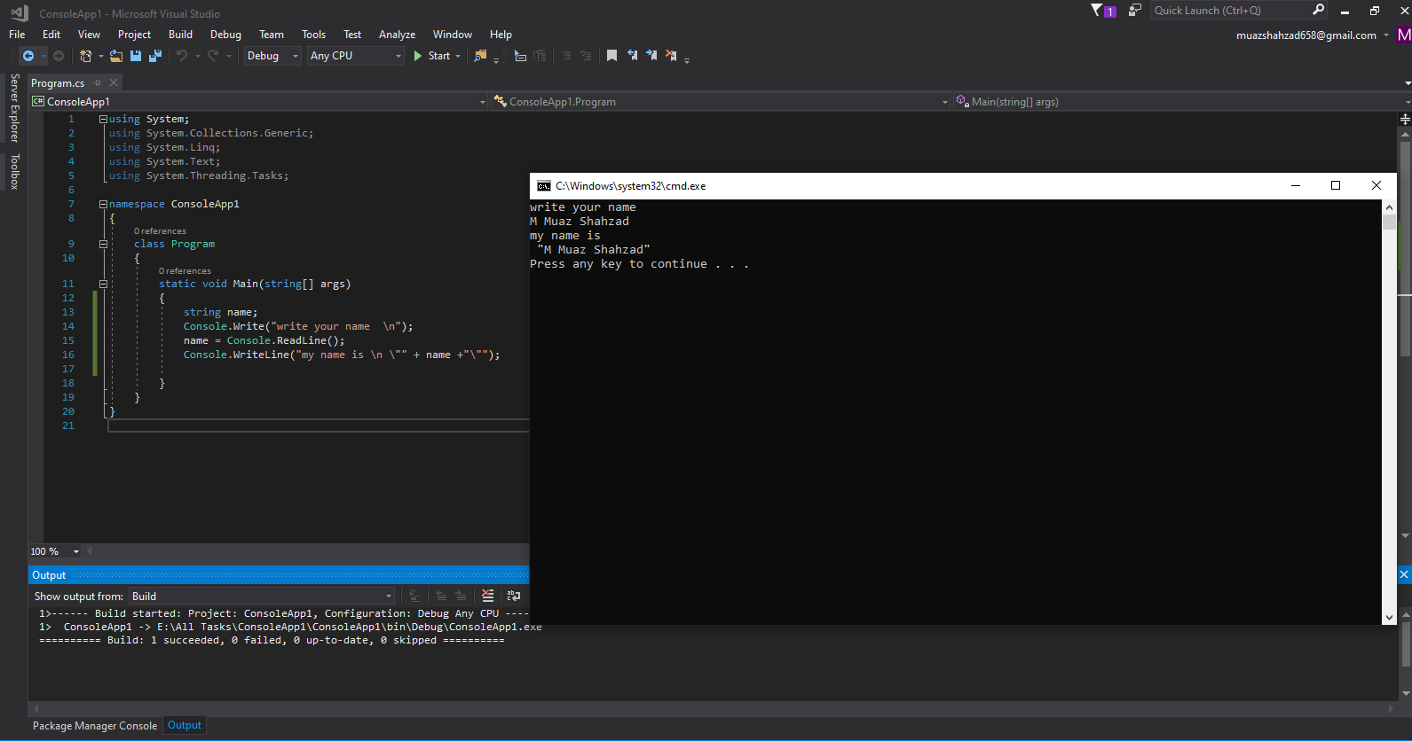

**Task no 3: Debugging the following program and write the values n, sum and m while debugging using system**

class SumExample

{

static void Main(string[] args)

{

int n, sum = 0, m;

Console.Write("Enter a number: ");

n = int.Parse(Console.ReadLine());

while (n > 0)

{

m = n % 10; //13 % 10 = 3 1 % 10 = 1

sum = sum + m; //sum = 0 + 3 ; sum = 3 + 1

n = m / 10; //13/10 = 1.3 (but int data type cannot store decimal

}

Console.Write("sum = " + sum); //Program Ends

}

}

**Solution:**

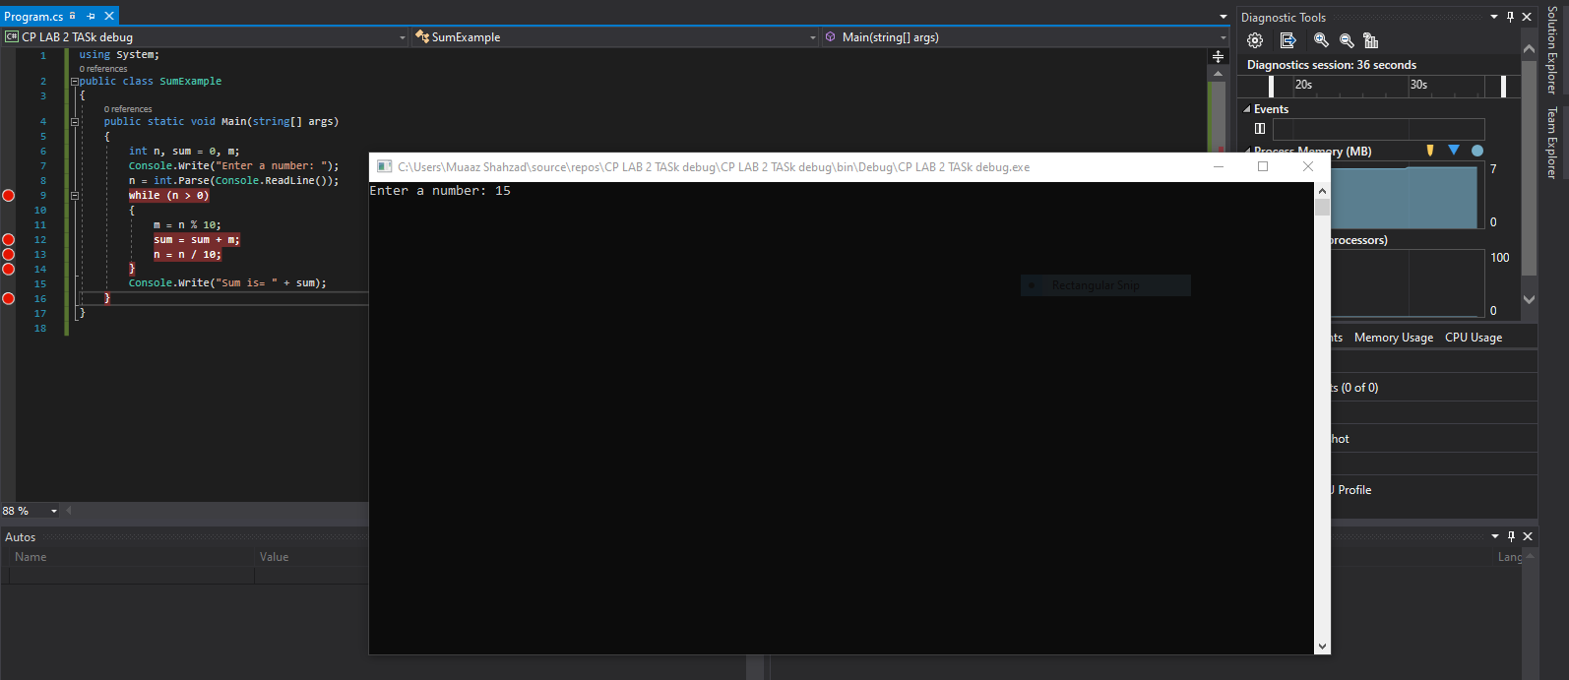

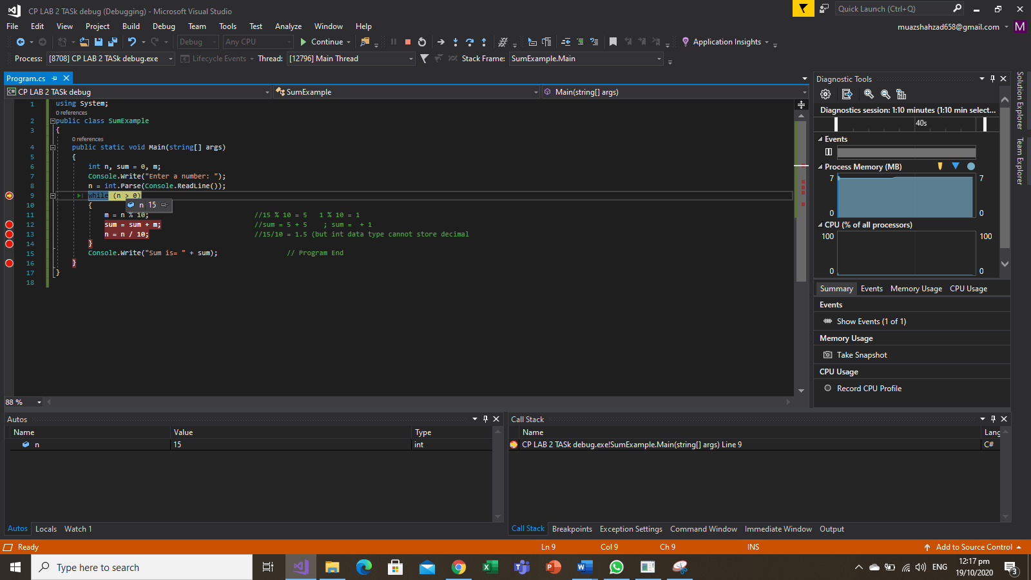

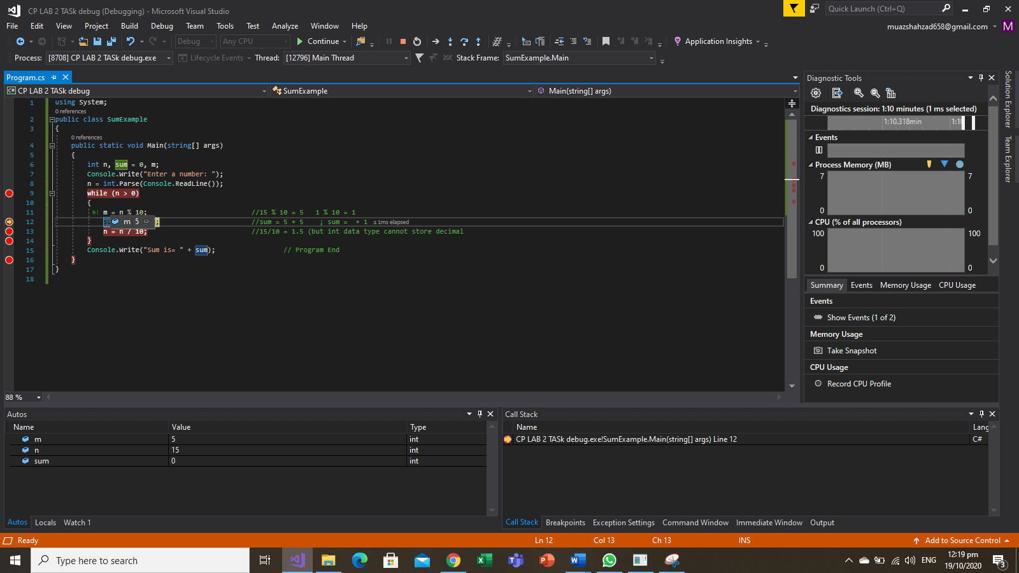

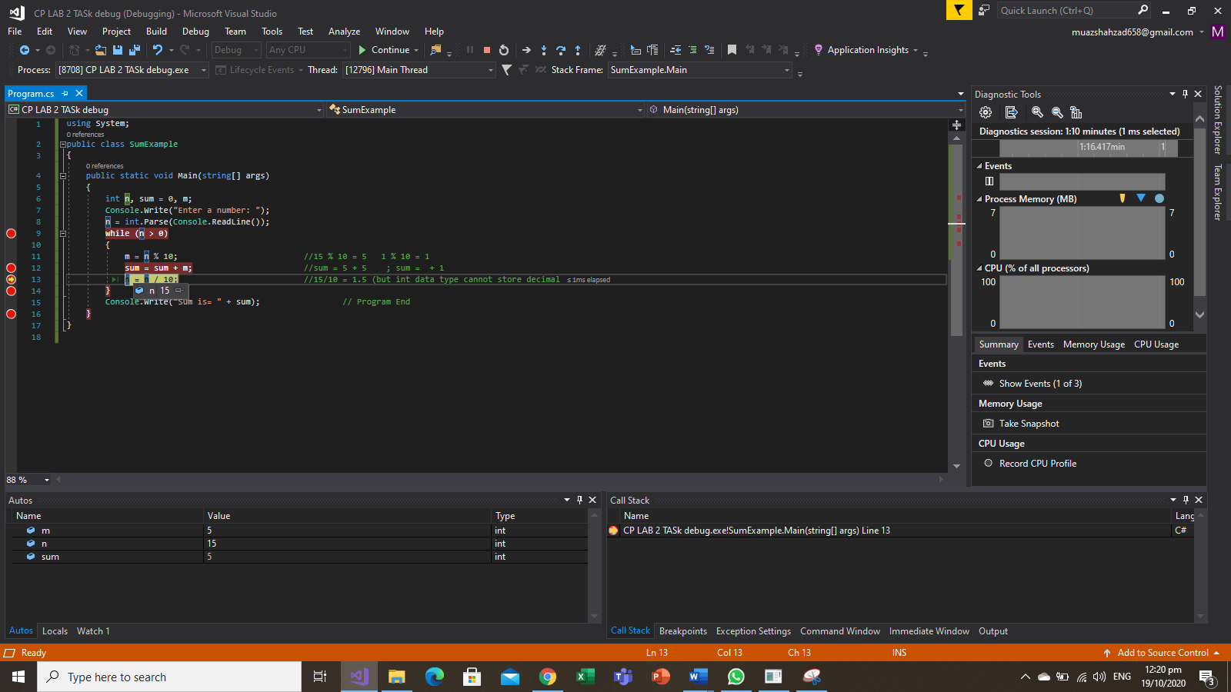

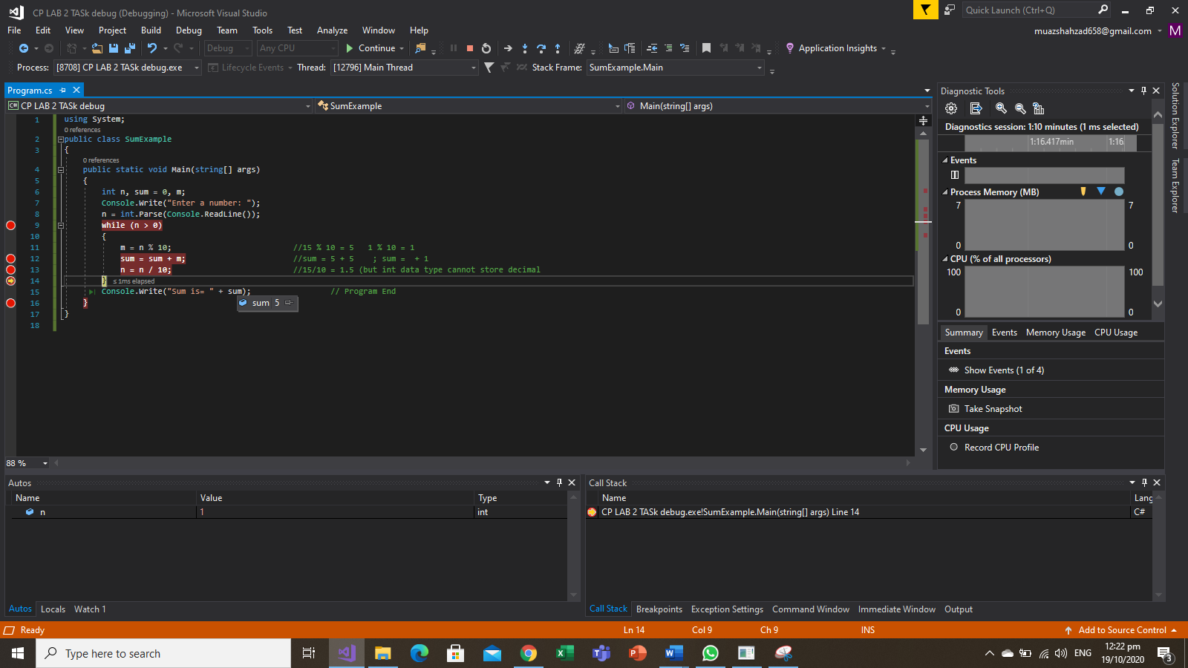

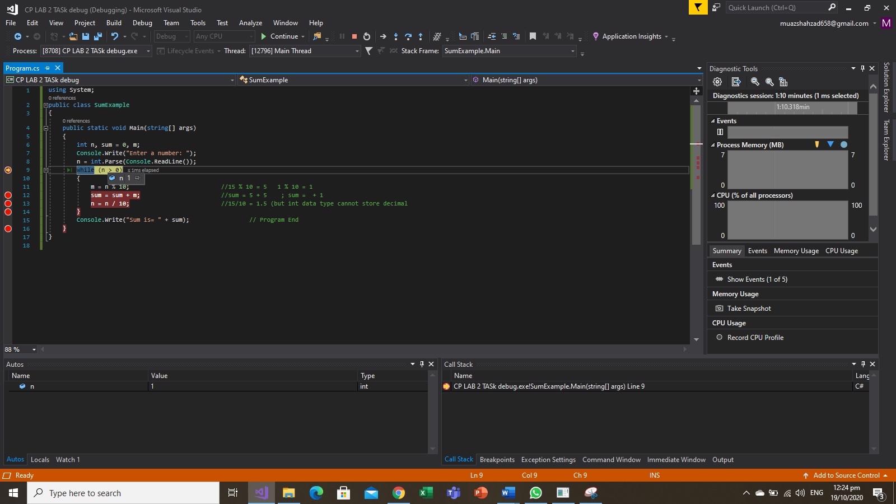

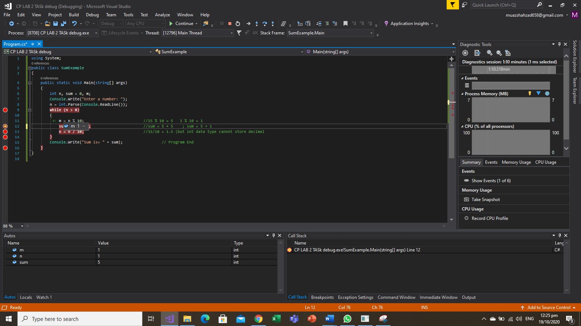

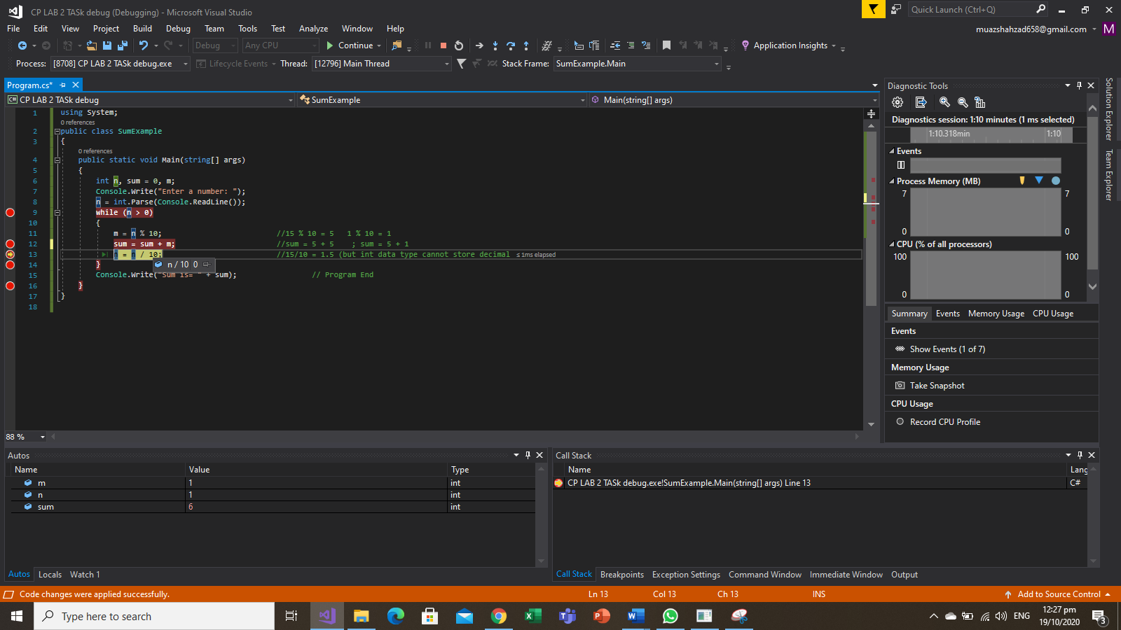

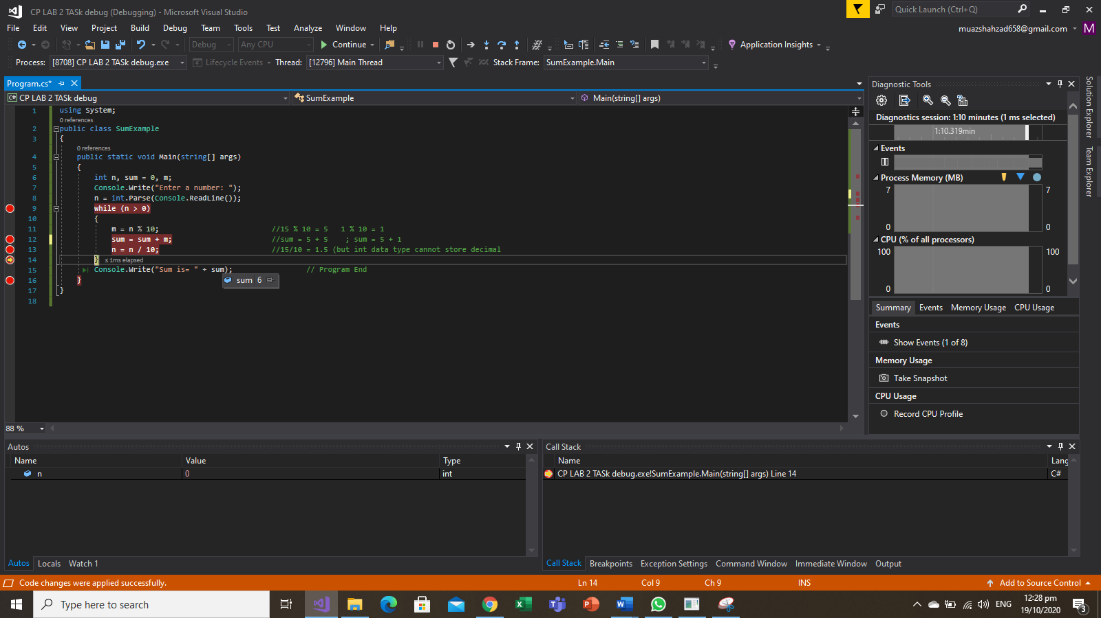

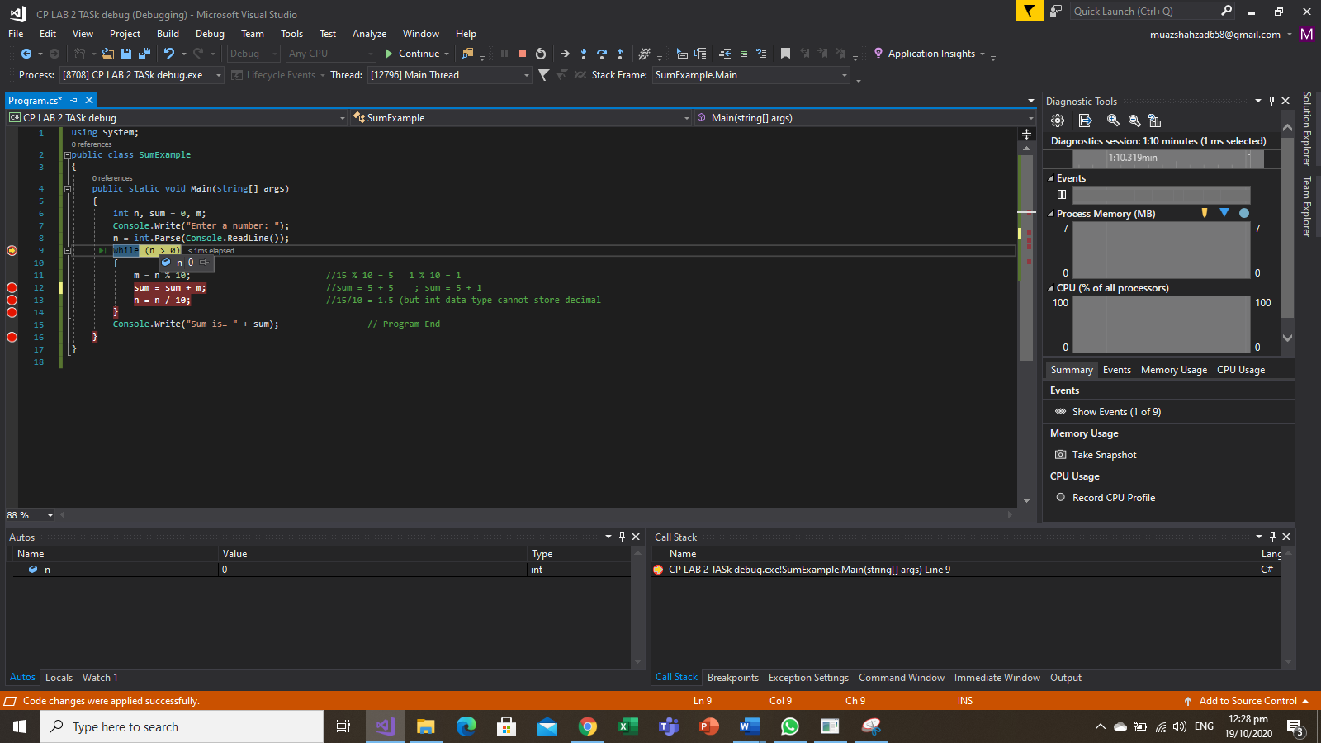

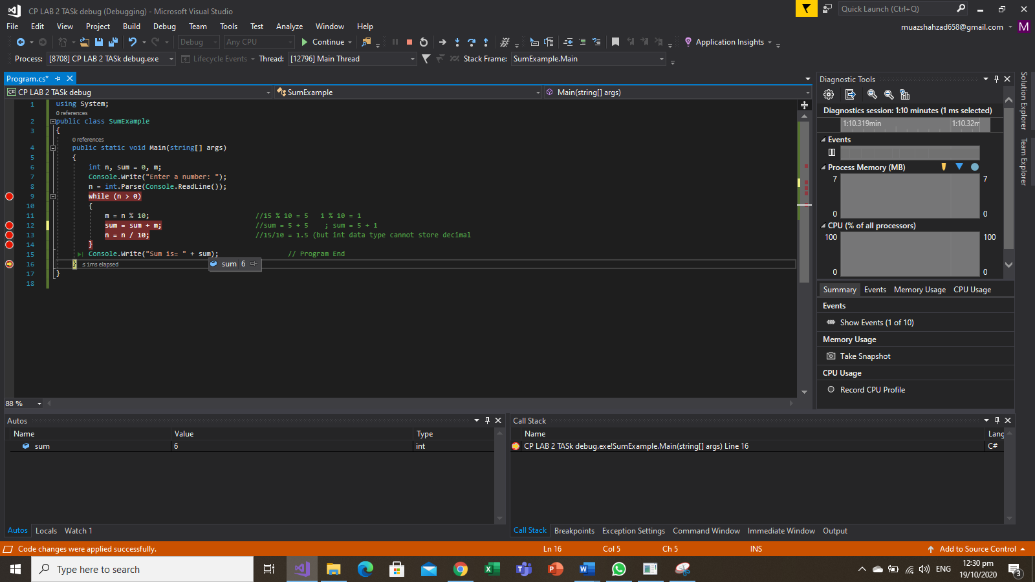

**Output: Without Debugging**

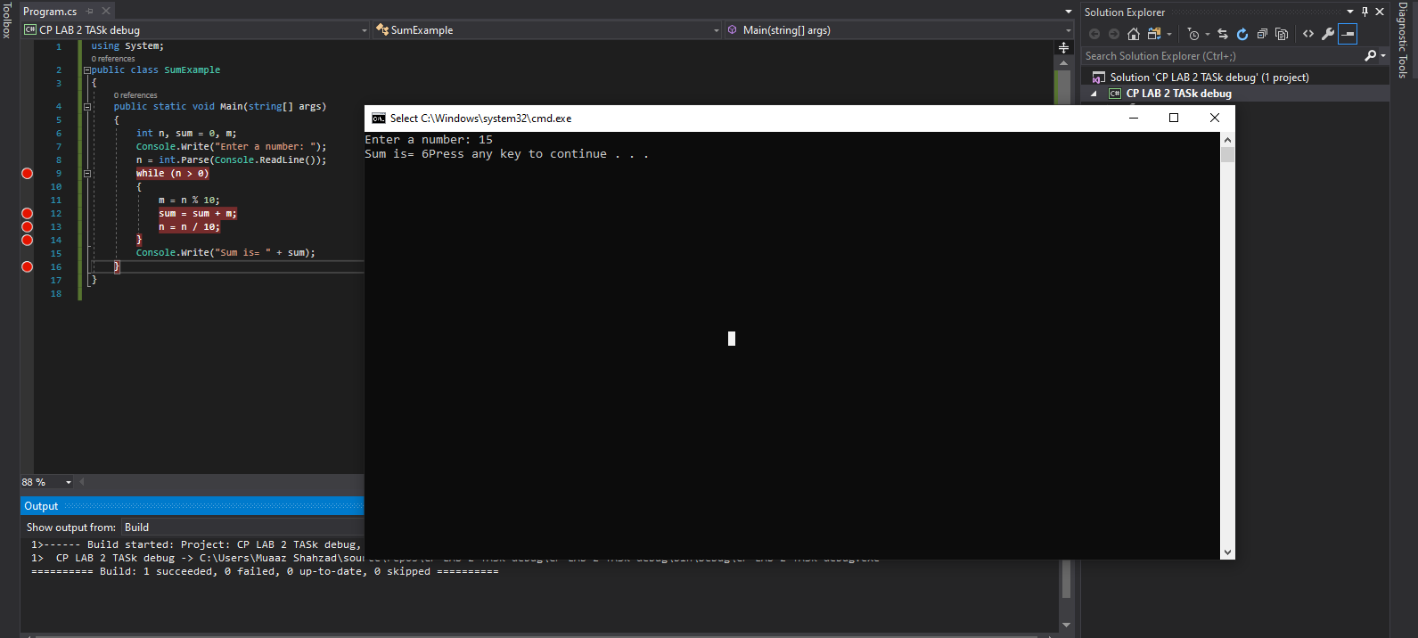

**Task No: 4 Execute the following program and show the ouput  
  
Solution:**

using System;

using System.Collections.Generic;

using System.Linq;

using System.Text;

using System.Threading.Tasks;

namespace ConsoleApp3

{

class Program

{

static void Main(string[] args)

{

int age;

string name;

Console.WriteLine("Enter your Name: ");

// using the method

// typecasting not needed

// as Readline returns string

name = Console.ReadLine();

Console.WriteLine("Enter your Age: ");

// Converted string to int

age = Convert.ToInt32(Console.ReadLine());

if (age >= 18)

{

Console.WriteLine("Hello " + name + "!" + " You can vote");

}

else

{

Console.WriteLine("Hello " + name + "!" + " Sorry you can't vote");

}

}

}

}

**Output:**

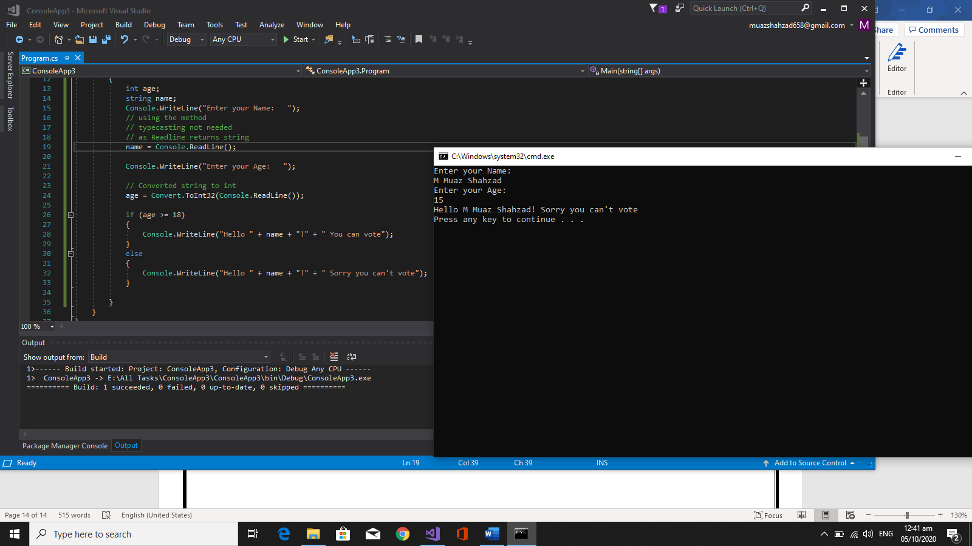

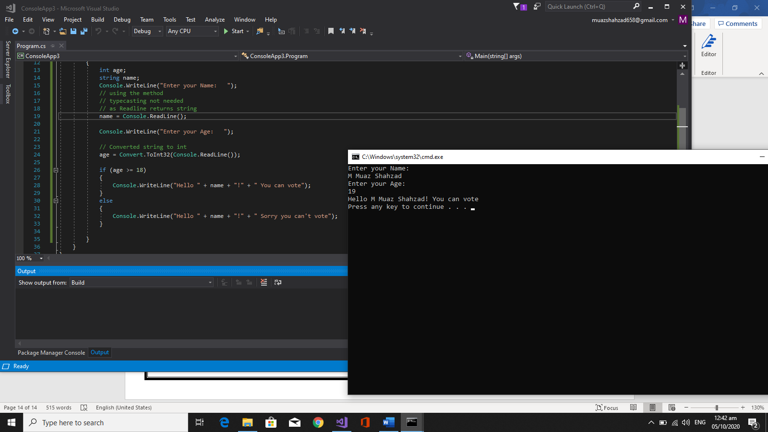

Bahria University,

Karachi Campus



LAB EXPERIMENT NO.

**02**LIST OF TASKS

|  |  |
| --- | --- |
| TASK NO | OBJECTIVE |
| 01 | Write a program to display your personal information. (Name, age, address, father’s name, college name, NIC, phone number etc. ) and display your marks sheet. ((Use Escape Sequences to create a formatted Output according to the given image). |
| 02 | Write a program to display you inter/matric marks sheet. |
| 03 | Write a C# program that display the result of the expressions   * 3.0*5.0 * 7.1*8.3-3.3 * 3.2/ (6.1*5) * 15/4 * 15%4 * 5*3-(6*4). |
| 04 | Calculate the temperature in Celsius using **integer** values: C = 5/9 * (F - 32) |
| 05 | Calculate the area of circle |
| 06 | Display the result of the expression: (((a + b) * (c * e * d)) – e)/f |
|  |  |
|  |  |
|  |  |
|  |  |
|  |  |
|  |  |
|  |  |
|  |  |
|  |  |

Submitted On:

21/10/2020

(Date: DD/MM/YY)

**Task No. 1:** Write a program to display your personal information. (Name, age, address, father’s name, college name, NIC, phone number etc. ) and display your marks sheet. ((Use Escape Sequences to create a formatted Output according to the given image).

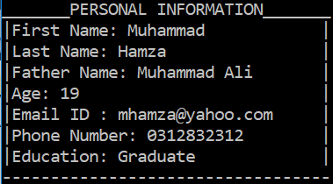

**Solution:**namespace CP_LAB_2_TASK_1

{

class Program

{

static void Main(string[] args)

{

string k = "M Muaz";

string n = "Shahzad";

string m = "M Shahzad";

string j = "18";

string l = "muazshahzad@gmail.com";

string o = "03162832684";

string p = "Undergraduate";

Console.WriteLine("_______PERSONAL INFORMATION_______");

Console.WriteLine("| First Name: " + k + " |");

Console.WriteLine("| Last Name : " + n + " |");

Console.WriteLine("| Father Name : " + m + " |");

Console.WriteLine("| Age : " + j + " |");

Console.WriteLine("| Email.ID:" + l + " |");

Console.WriteLine("| Phone Numbr : " + o + " |");

Console.WriteLine("| Education: " + p + " |");

Console.WriteLine("------------------------------------");

}

}

}

**Output:**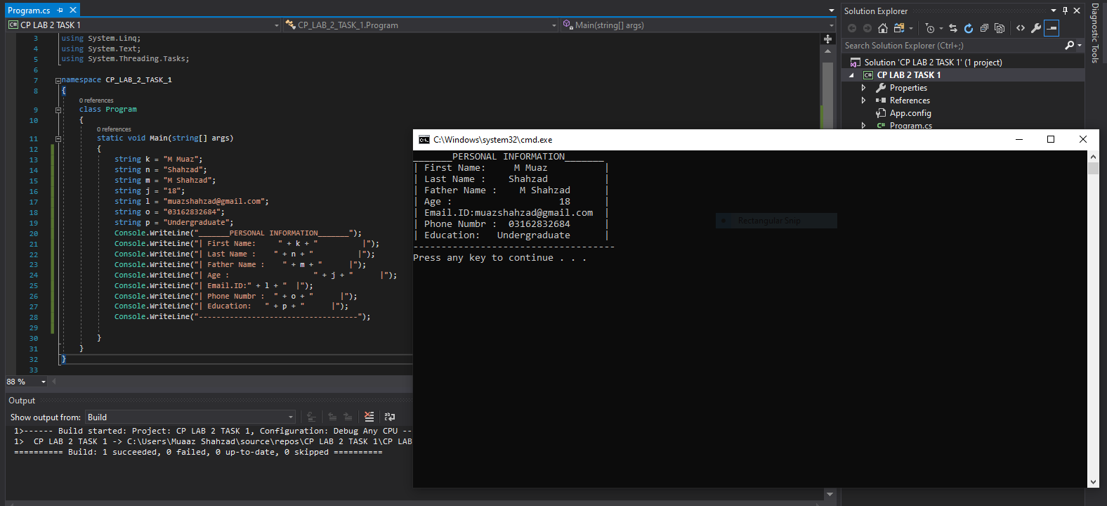

**Task No. 2**: **Write a program to display you inter/matric marks sheet.  
  
Solution:**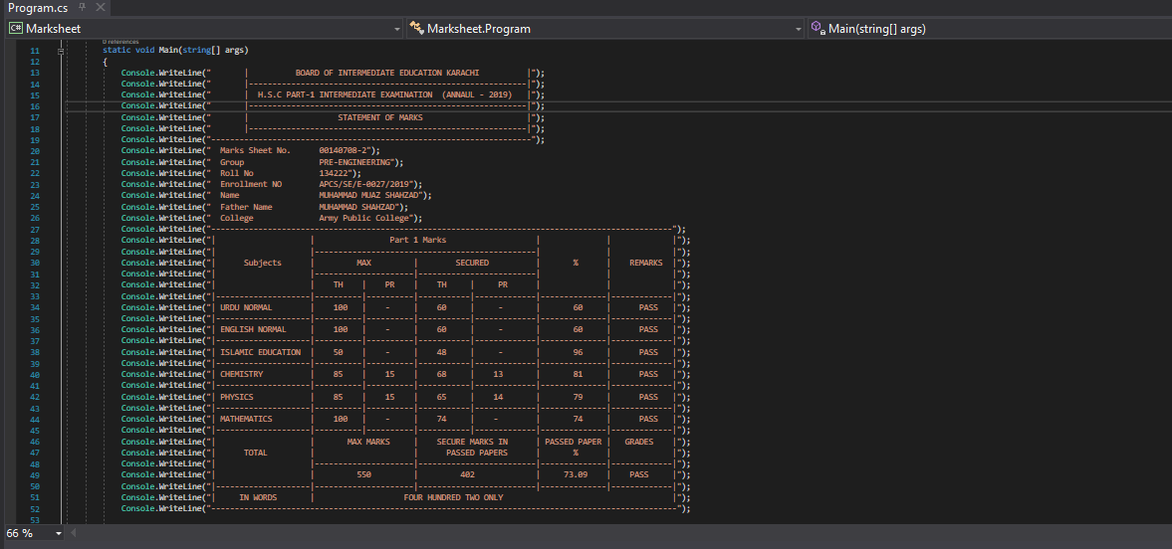  
**Output:**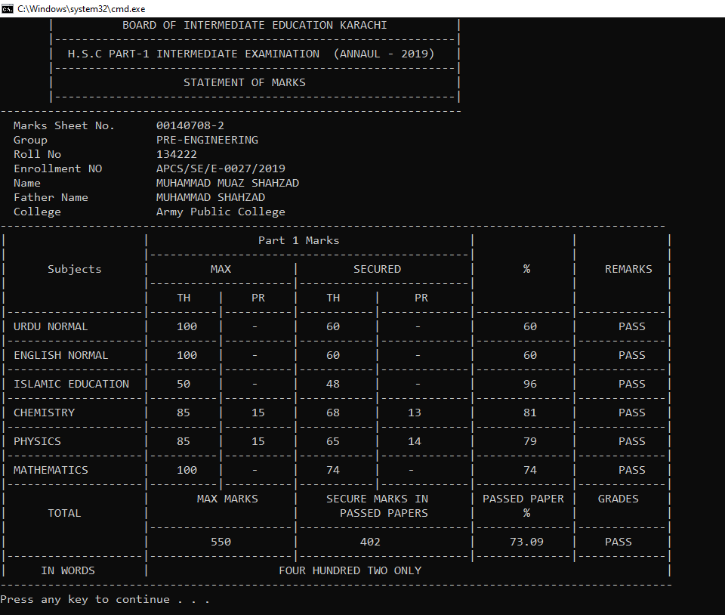

**Task No. 3:** Write a C# program that displays the results of the expressions:

* 3.0*5.0
* 7.1*8.3-2.2
* 3.2/ (6.1*5)
* 15/4
* 15%4
* 5*3-(6*4).

**Solution:**namespace ConsoleApp6

{

class Program

{

static void Main(string[] args)

{

Console.WriteLine(" 3.0 * 5.0 = " + ( 3.0 * 5.0));

Console.WriteLine(" 7.1 * 8.3 - 2.2 = " + (7.1 * 8.3 - 2.2));

Console.WriteLine(" 3.2 / (6.1 * 5) = " + (3.2 / (6.1 * 5)));

Console.WriteLine(" 15 / 4 = " + (15 / 4));

Console.WriteLine(" 15 % 4 = " + (15 % 4));

Console.WriteLine(" 5 * 3 - (6 * 4) = " + (5*3-(6*4)));

}

}

}

**Output:**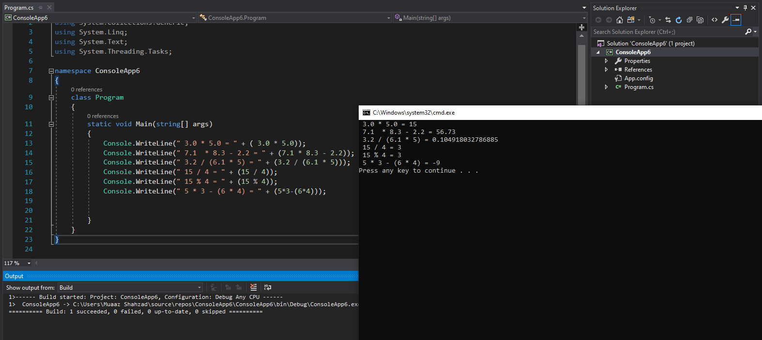

**Task No. 4:** Calculate the temperature in Celsius using **integer** values.

C = 5/9 * (F – 32)

**Solution:**

namespace temp_tasks

{

class Program

{

static void Main(string[] args)

{

double F = 100;

double C;

C = 5 * (F - 32) / 9;

Console.WriteLine("C = 5 / 9 (F - 32) = " + C);

}

}

}

**Output:** 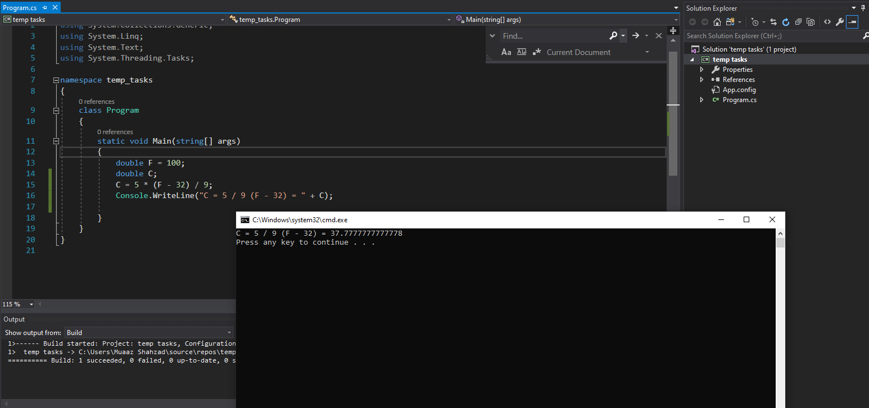

**Task No. 5:** **Calculate the area of Circle.**

**Solution:**namespace CP_LAB_2_TASKS_5

{

class Program

{

static void Main(string[] args)

{

int R = 20;

double pie = 3.14, a;

Console.WriteLine("Radius= " + R);

a = pie * (R * R);

Console.WriteLine("Area= " + a);

}

}

}

**Output:**

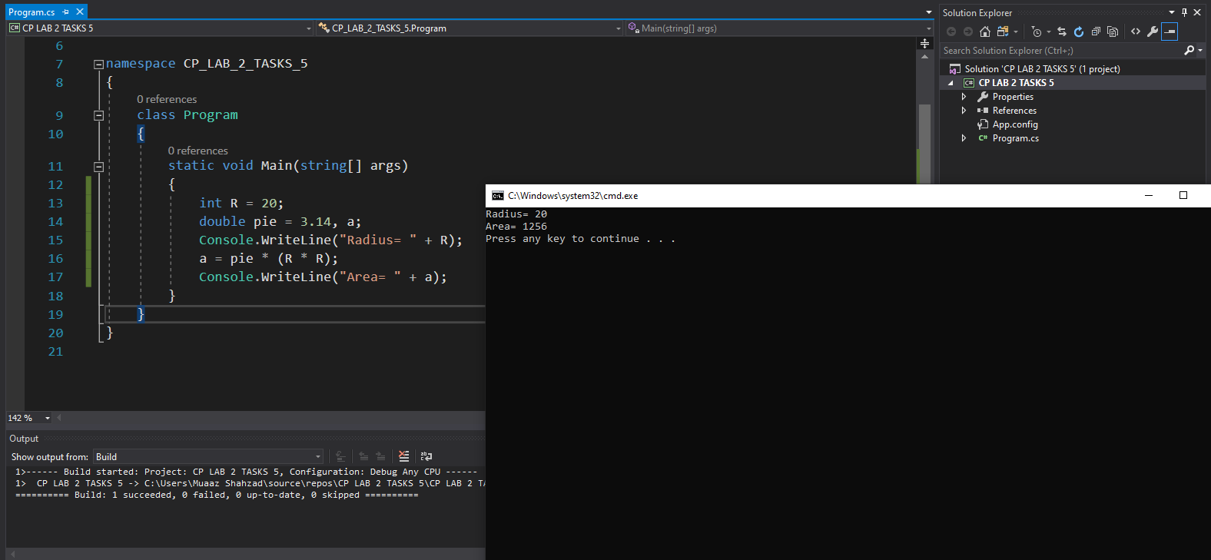

**Task No. 6: Display the result of the expression:**

**((( a + b) * (c * e * d)) – e)/f  
  
 Solution:**

namespace Task_7

{

class Program

{

static void Main(string[] args)

{

int a, b, c, d, e, f;

a = 2;

b = 4;

c = 6;

d = 8;

e = 10;

f = 12;

Console.WriteLine("Given Expression is ((( a + b) * (c * e * d)) - e)/f");

Console.WriteLine("The result of expression is = " +(((a + b) * (c * e * d)) - e) / f);

}

}

}

**Output:** 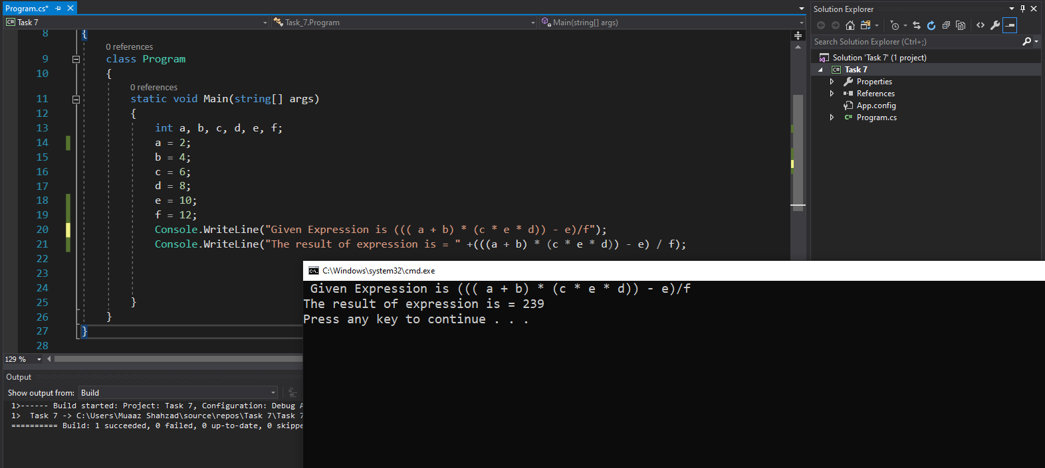 Bahria University,

Karachi Campus



LAB EXPERIMENT NO.

**03**LIST OF TASKS

|  |  |
| --- | --- |
| TASK NO | OBJECTIVE |
| 01 | Write a code which take two integer values from user and perform mathematical operations (Addition, Subtraction, Multiplication and Division) on these two values. |
| 02 | Write a program to take personal information from user and display it. |
| 03 | Calculate the quadratic equation by using three user given integer variables. |
| 04 | Take input of user personal information and HSSC/SSC subjects marks. By using the given information generate Marks Sheet. |
| 05 | Display the following results and take value of a, b, c, d, e, and f from user. ( ( ( b + 3 ) ^ ( 4 a c) ) / d ) * ( ( ( a * c ) + ( b * d ) ) * f ) |
| 06 | Write a program and print the output of first equation of the motion. For values take input from user. |
|  |  |
|  |  |
|  |  |
|  |  |
|  |  |
|  |  |
|  |  |

Submitted On:

21/10/2020

(Date: DD/MM/YY)

**Task No. 1:** Write a code which take two integer values from user and perform mathematical operations (Addition, Subtraction, Multiplication and Division) on these two values.  
  
**Solution:** namespace CP_lab_3_Tsk

{

class Program

{

static void Main(string[] args)

{

int a, b, multiplication, division, addition, substraction;

Console.WriteLine("Mathematical Operations");

Console.Write("Put value of a = ");

a = Convert.ToInt32(Console.ReadLine());

Console.Write("Put value of b = ");

b = Convert.ToInt32(Console.ReadLine());

multiplication = (a * b);

Console.WriteLine("a * b = " + multiplication);

division = (a / b);

Console.WriteLine("a / b = " + division);

addition = (a + b);

Console.WriteLine("a + b = " + addition);

substraction = (a - b);

Console.WriteLine("a - b = " + substraction);

}

}

}

**Output: 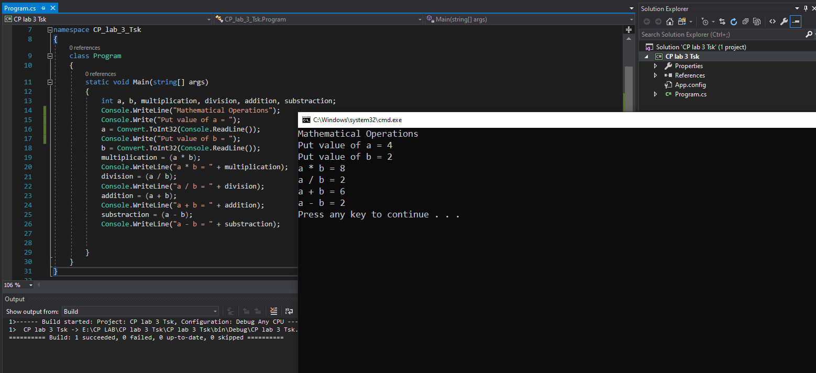 Task No. 2: Write a program to take personal information from user and display it.  
  
Solution:** namespace CP_lab_3_task_2

{

class Program

{

static void Main(string[] args)

{

String firstName, lastName, fatherName, emailId, education;

int age;

float phone;

Console.WriteLine("________Personal Confirmation________");

Console.Write("FirstName = ");

firstName = Console.ReadLine();

Console.Write("LastName = ");

lastName = Console.ReadLine();

Console.Write("Father Name = ");

fatherName = Console.ReadLine();

Console.Write("Age = ");

age = Convert.ToInt32(Console.ReadLine());

Console.Write("Phone = ");

phone = Convert.ToInt64(Console.ReadLine());

Console.Write("Email ID = ");

emailId = Console.ReadLine();

Console.Write("Education = ");

education = Console.ReadLine();

}

}

}

**Output:**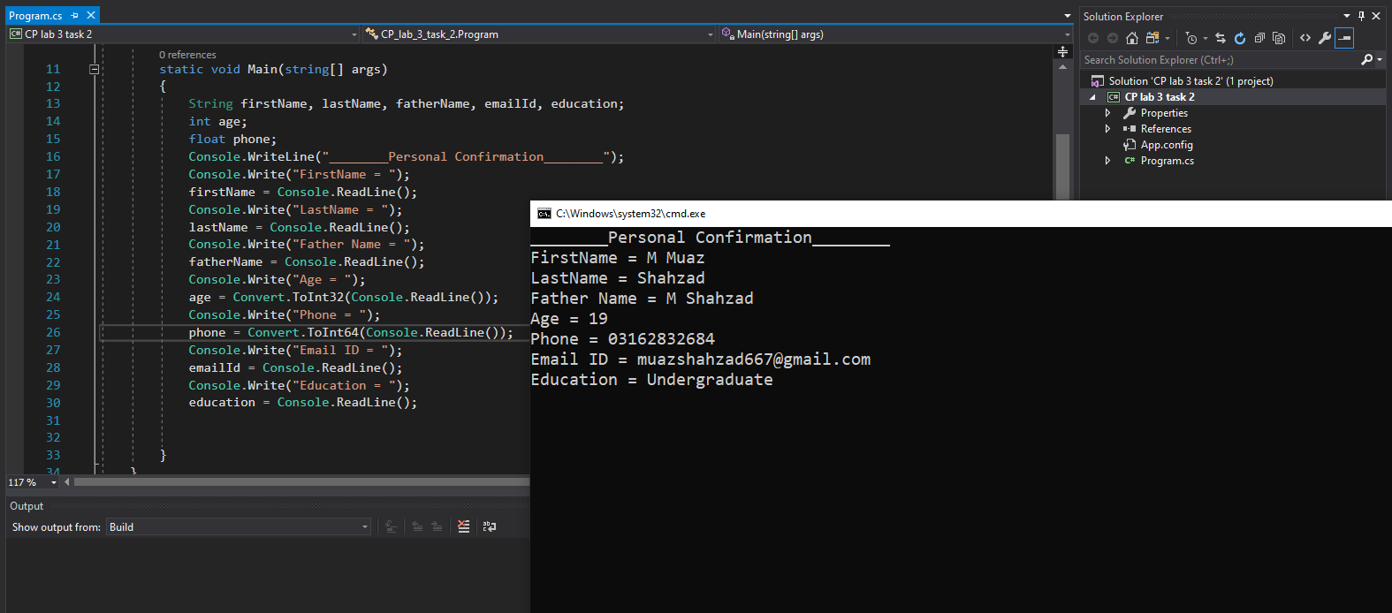

**Task No. 3: Calculate the quadratic equation by using three user given integer variables.  
  
Solution:**namespace CP_lab_3_task_03

{

class Program

{

static void Main(string[] args)

{

int a, b, c;

Console.Write("A = : ");

a = Convert.ToInt32(Console.ReadLine());

Console.Write("B = : ");

b = Convert.ToInt32(Console.ReadLine());

Console.Write("C = : ");

c = Convert.ToInt32(Console.ReadLine());

double g = Math.Pow(b , 2);

double h = g - (4 * a * c);

double sqr = Math.Sqrt(h);

Console.WriteLine("Quardatic Equation's Result x1 = : " + ((-b + sqr) / (2 * a)));

Console.WriteLine("Quadratic Equation's Result x2 = : " + ((-b - sqr) / (2 * a)));

}

}

}

**Output:**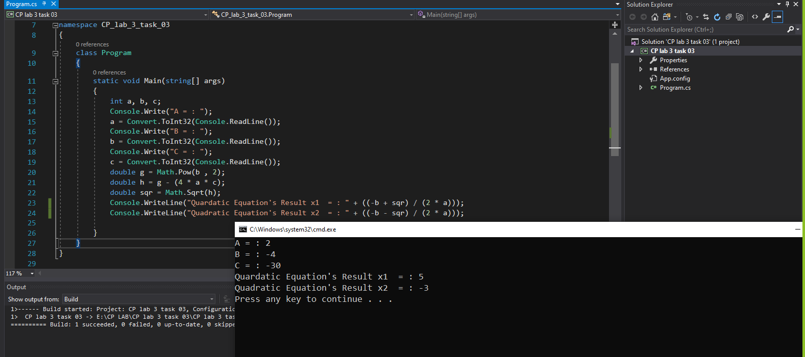

**Task No. 4: Take input of user personal information and HSSC/SSC subjects marks. By using the given information generate Marks Sheet.**

**Solution:** 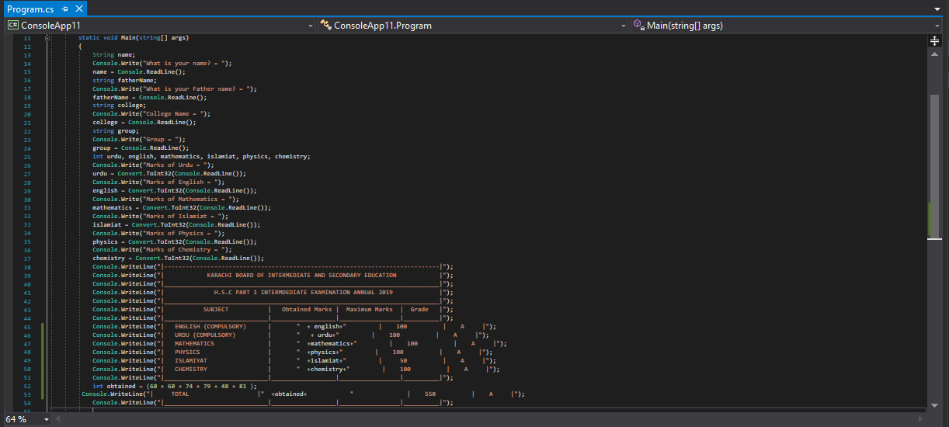

**Output:**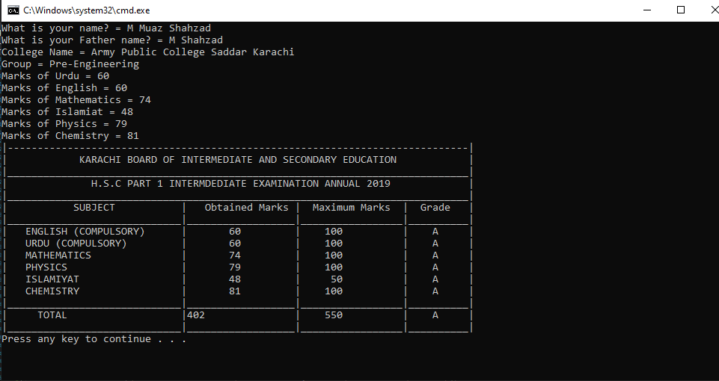

**Task No. 5:** **Display the following results and take value of a, b, c, d, e, and f from user. ( ( ( b + 3 ) ^ ( 4 a c) ) / d ) * ( ( ( a * c ) + ( b * d ) ) * f )   
  
Solution:** namespace ConsoleApp1

{

class Program

{

static void Main(string[] args)

{

int a, b, c, d, e, f, j, k, l, m;

Console.Write("Enter a num for A : ");

a = Convert.ToInt32(Console.ReadLine());

Console.Write("Enter a num for B : ");

b = Convert.ToInt32(Console.ReadLine());

Console.Write("Enter a num for C : ");

c = Convert.ToInt32(Console.ReadLine());

Console.Write("Enter a num for D : ");

d = Convert.ToInt32(Console.ReadLine());

Console.Write("Enter a num for E : ");

e = Convert.ToInt32(Console.ReadLine());

Console.Write("Enter a num for F : ");

f = Convert.ToInt32(Console.ReadLine());

j = b + 3;

k = 4 * a * c;

l = a * c;

m = b * d;

double r = Math.Pow(j, k);

Console.WriteLine("RESULT OF MATHEMATICAL EXPRESSION = " + (((r / d)) * ((l + m) * f)));

}

}

}

**Output:**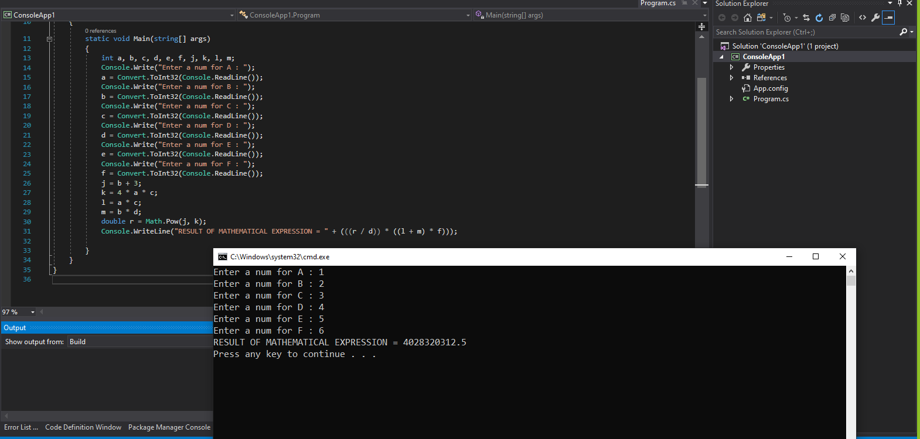

**Task No. 6: Write a program and print the output of first equation of the motion. For values take input from user.**

**Solution:** namespace CP_LAB_TASKS_5

{

class Program

{

static void Main(string[] args)

{

int vF, vI, a, t;

Console.Write("vi = : ");

vI = Convert.ToInt32(Console.ReadLine());

Console.Write("a = : ");

a = Convert.ToInt32(Console.ReadLine());

Console.Write("T = : ");

t = Convert.ToInt32(Console.ReadLine());

Console.WriteLine("vf = vi + a * t = " + (vI + (a * t)));

}

}

}

**Output:** 